**Steps for LAMBDA FUNCTION CREATION..for cost optimization..usecase..**

1. **Goto AWS console serach for aws lambda in search bar**
2. **Create a function by selecting the option**
3. **Created instances for testing purpose…**

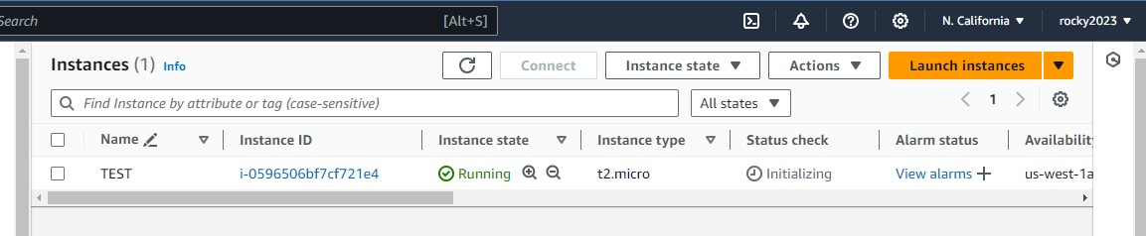

1. **Defaultly volume will created next from that volume snapshot created…**

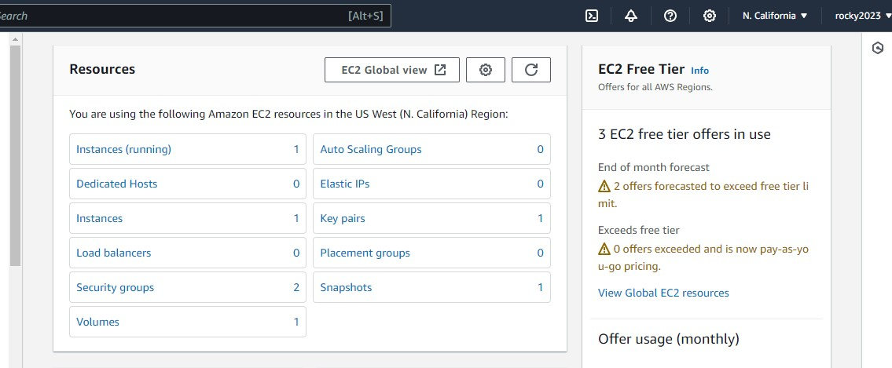

1. **Created new LAMBDA FUNCTION..**

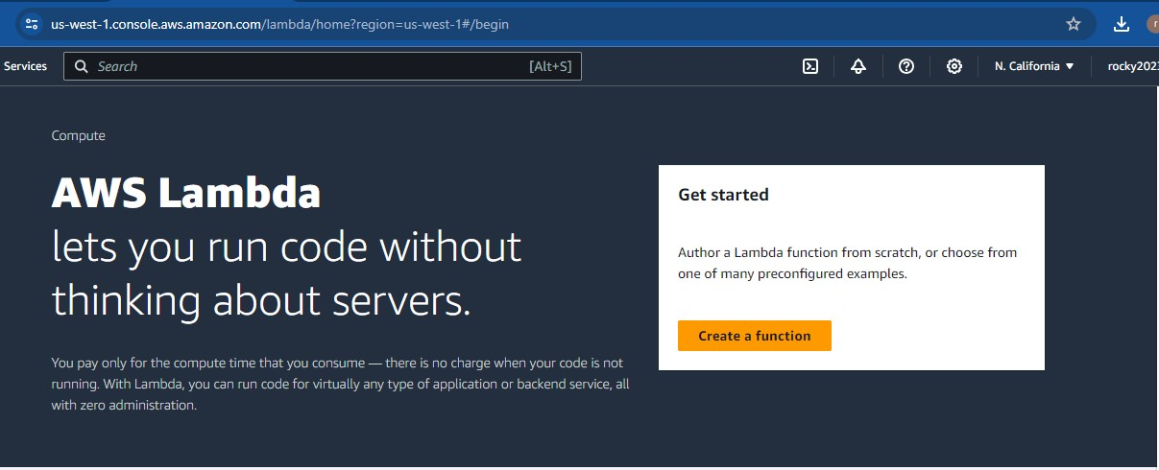

**6. Adding basic information ..**

**1.Like function name..**

**2.Runtime info like application selection..**

**3.Selected python application ..**

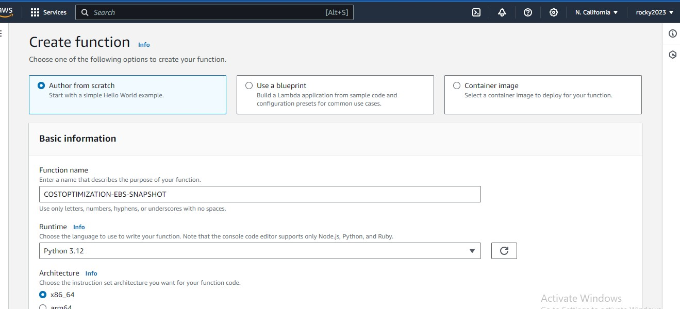

1. Created new function succesfully… 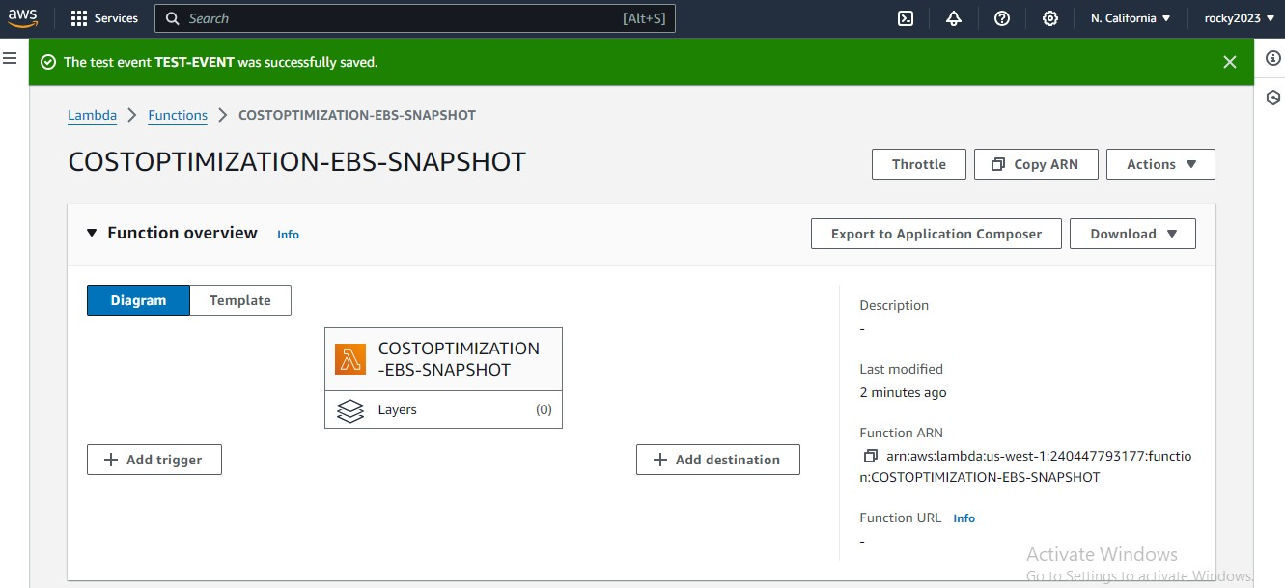
2. **Added python code …At test area in CODE SECTION it was taken from outer sources..**
3. After adding the code deploy it..next select option test ..it will through new popup
4. Like add event name it and save it …
5. Next step for this purpsoe have to give some permissions …to work code properly..
6. So have to create new policy and role and attach to the lambda function…

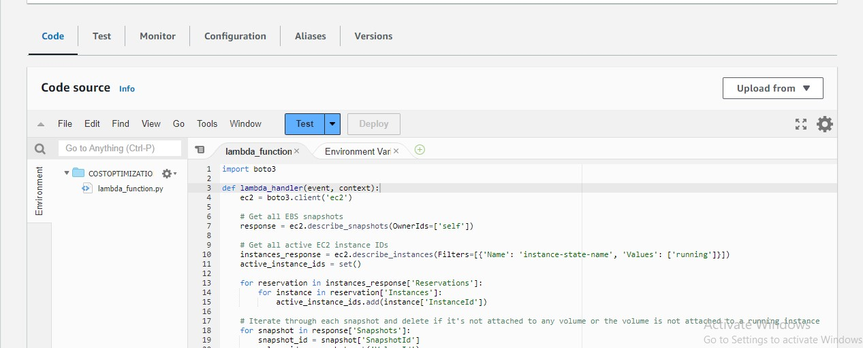

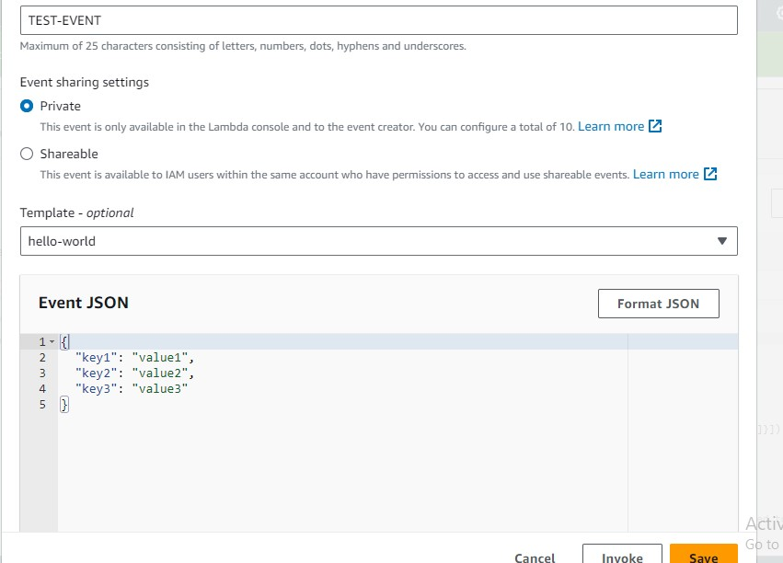

1. **Here tested the code but code not success its failed due to not added proper permission to this function….so have to create role and policy for this to work..properly**

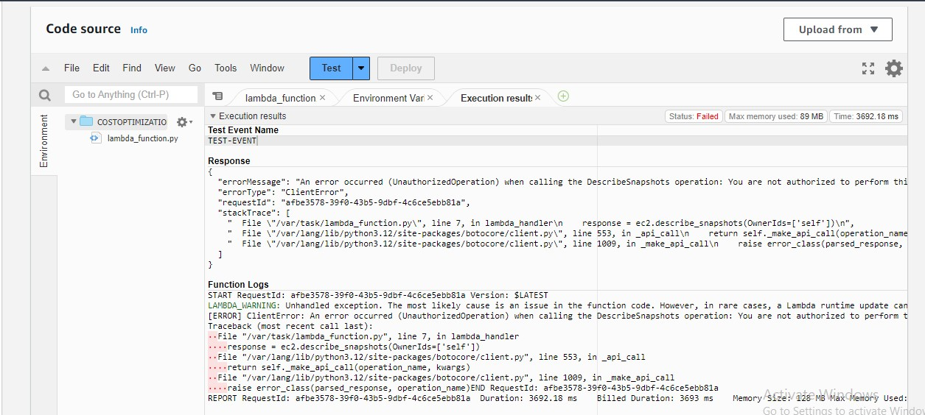

1. **For creating role go to configuration select permissions in that click on the role name its redirected to IAM INTERFACE ,,their will create policy and role..**

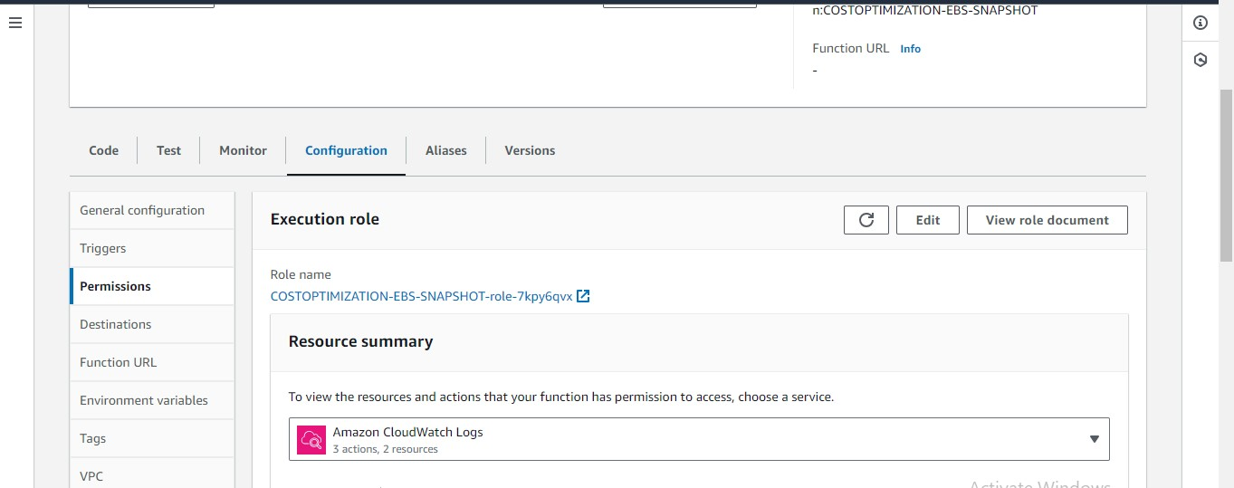

1. **Create policy …in that select snapshot decsribe what we want like**
2. **Like describe snapshots,delete snopshots….**
3. **After selecting create the policy..**

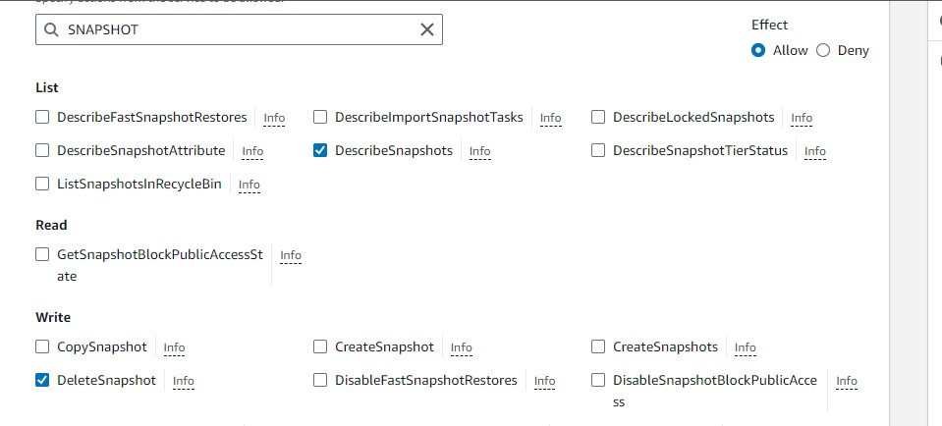

1. **Policy has been created succesfully and next create role and attach the policy..**

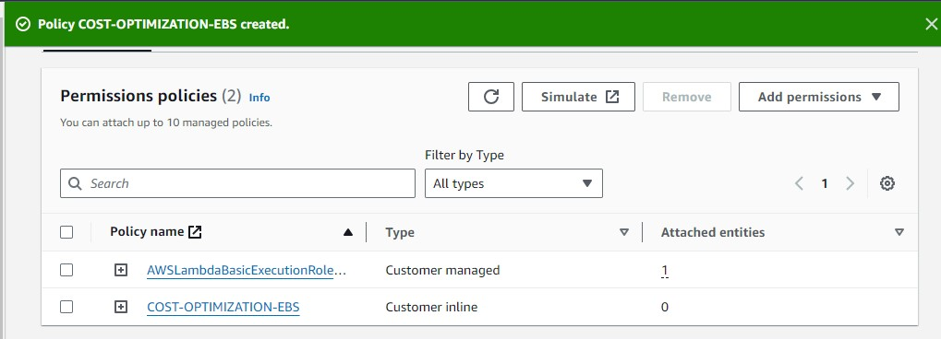

1. **Policy attached to the role successfully…**

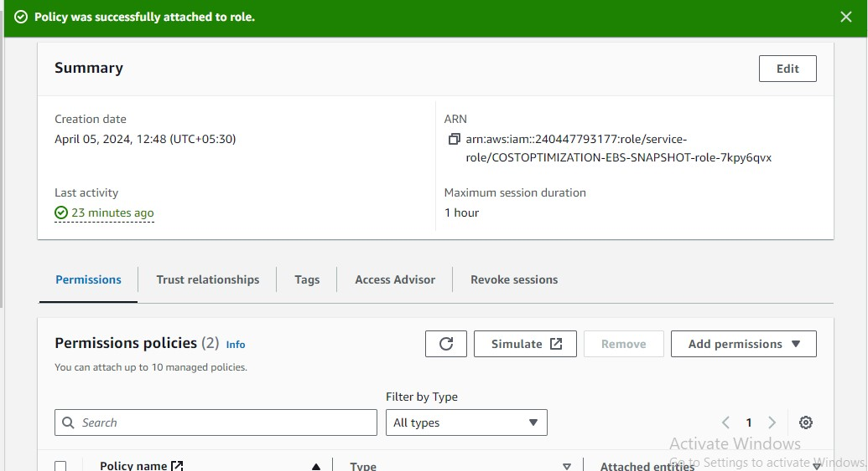

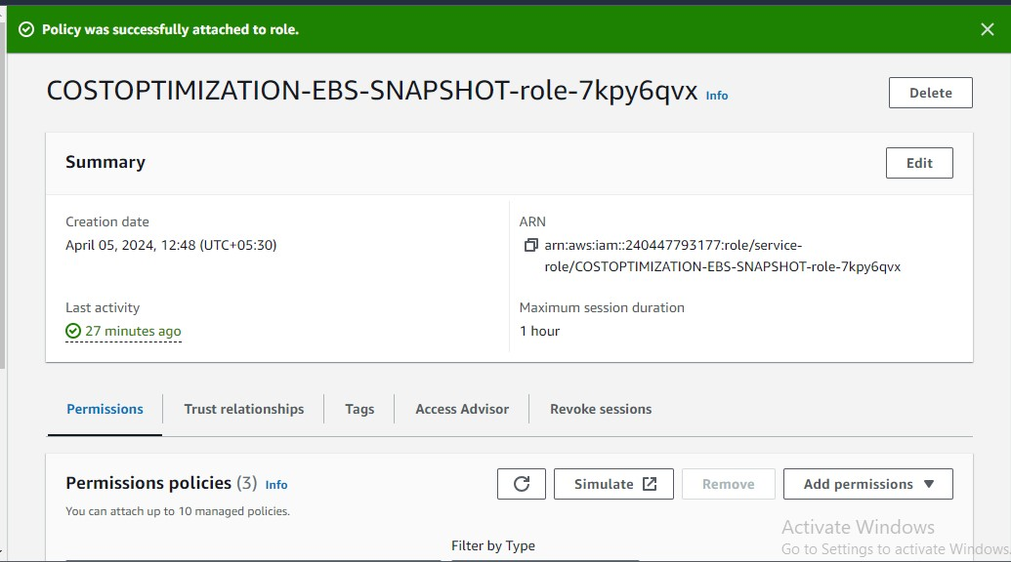

1. **Code Run Succesfull after adding role to this function its manually invoking lambda function…**

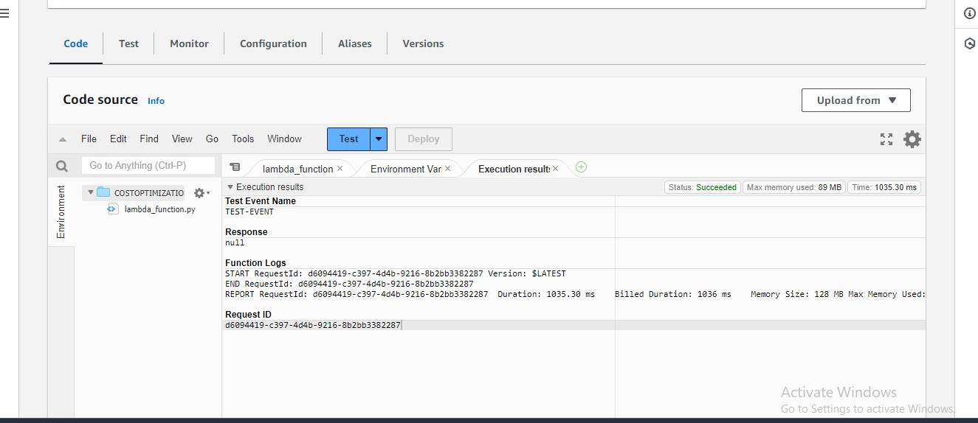

1. **Next terminated the instances bec as per coed have to delete the unsable snapshots..so and also volume will be deleted automatically bec it defaultly created with ec2instance…**

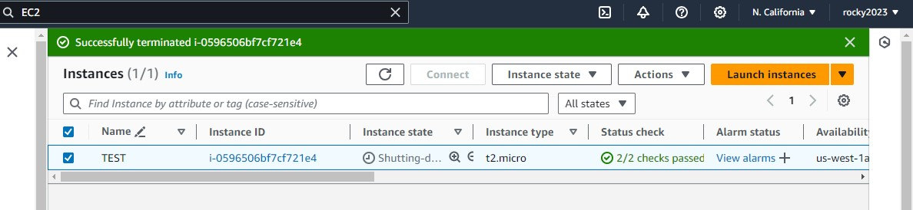

1. **Below image shown clearly the instance is not available but snapshot available…**

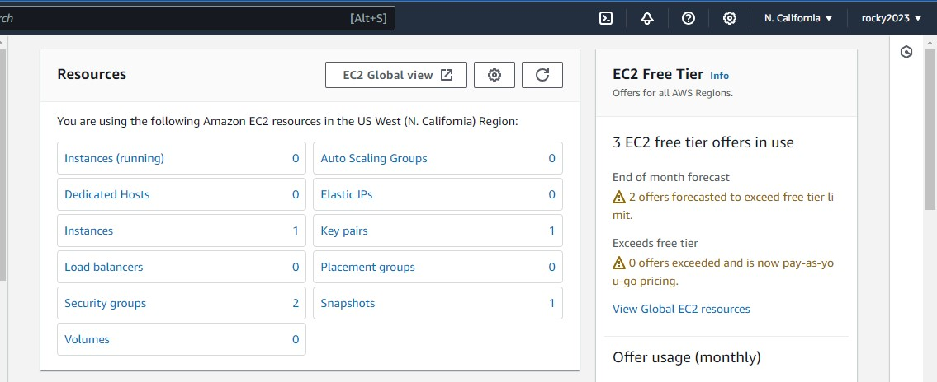

1. **Again invoke the code its got success mean it had deleted the snapshots..…**

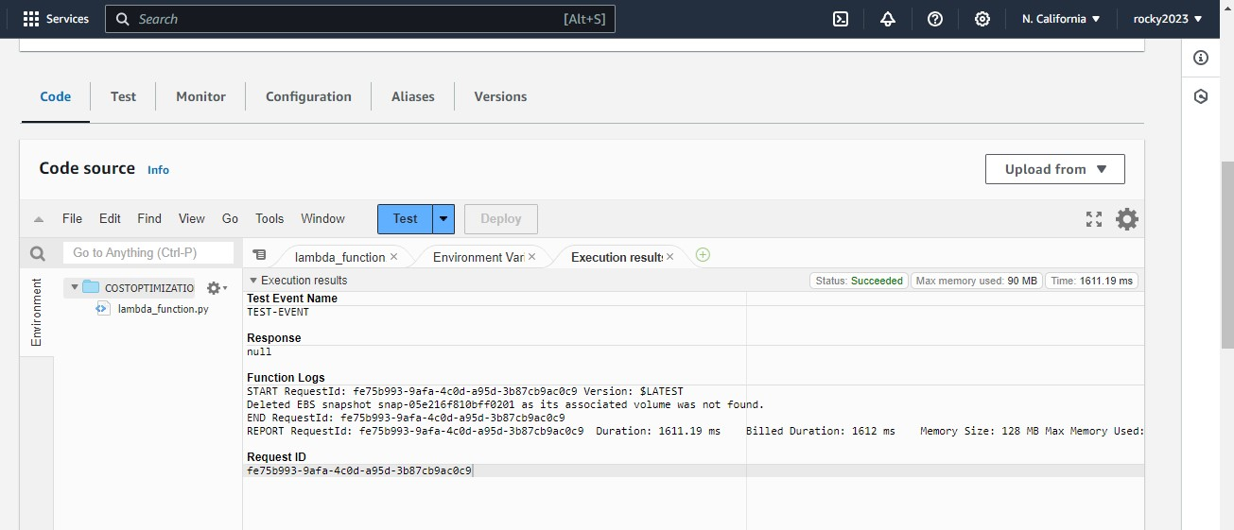

**Actually its deleted the volume bec above image shown successful after invokin…but slide has got deleted so ….**

**Next job lambda functioning from cron job for stopping and terminating the ec2instances…**

**Steps for cron schedule…with new code and new instances..**

1. **First create policy and role …Attach the policy to the role..**
2. **Create instances ..**
3. **Create lambda function..attach the role what we created..**
4. **Next create event bridge …**

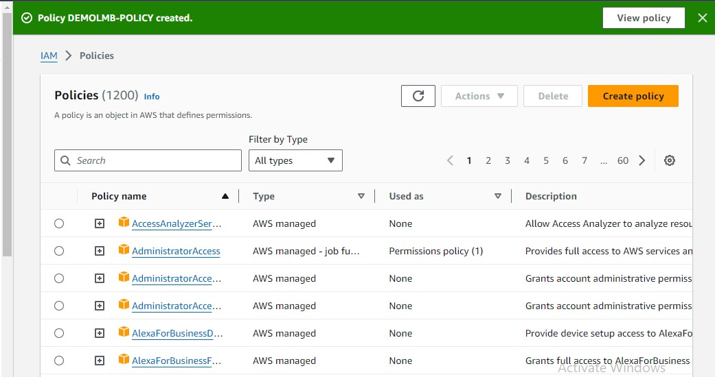

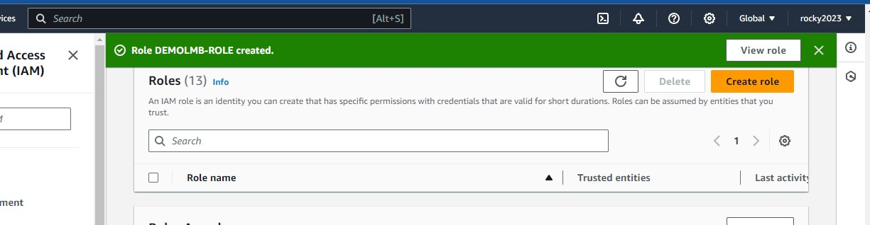

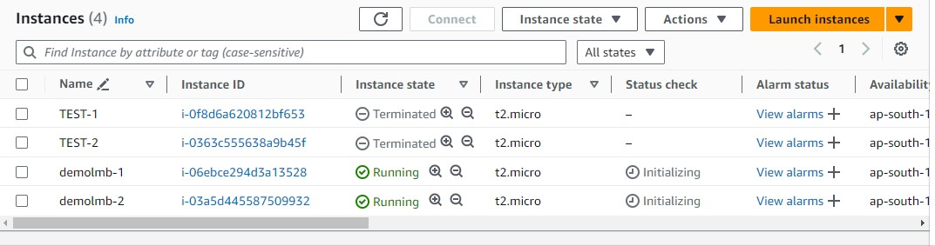

1. **Steps for creating lambda function…go to Aws console search for aws lambda …it will redirected to aws lambda interface..**
2. **Select Create a function…**
3. **In create function add next select the option like Author from scratch and add basic information…**
4. **Like function name,runtime info( application info),in that select python 3.8..**





1. **Next in permissions..select change default execution rule..**
2. **Select the use an existing role option to add what we created the role …**

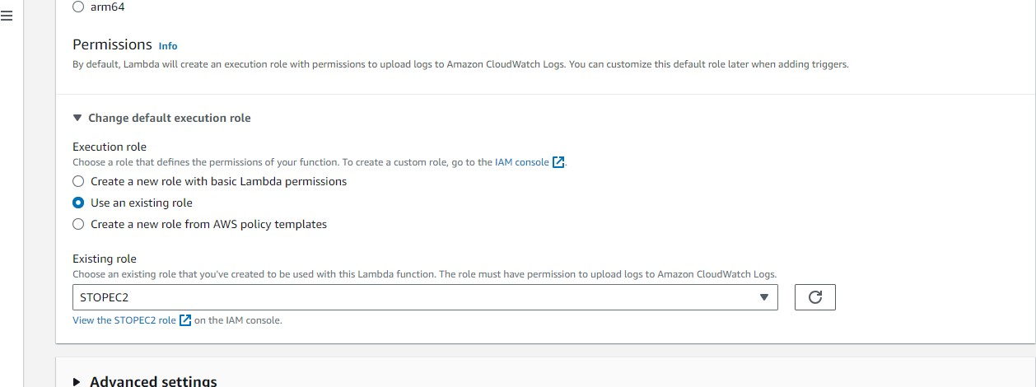

1. **After creating Function go to code section in that select test add code in that section…**
2. **Code for to start stop and terminate instances…**
3. **Add code to the test next deploy it after that select test..**
4. **After selecting test it will goto events create event by adding event name and create it…**
5. **But do some changes in code like adding region in which your working region..**
6. **Add isntances IDS at code where it represnts instance ids…its must to do…**

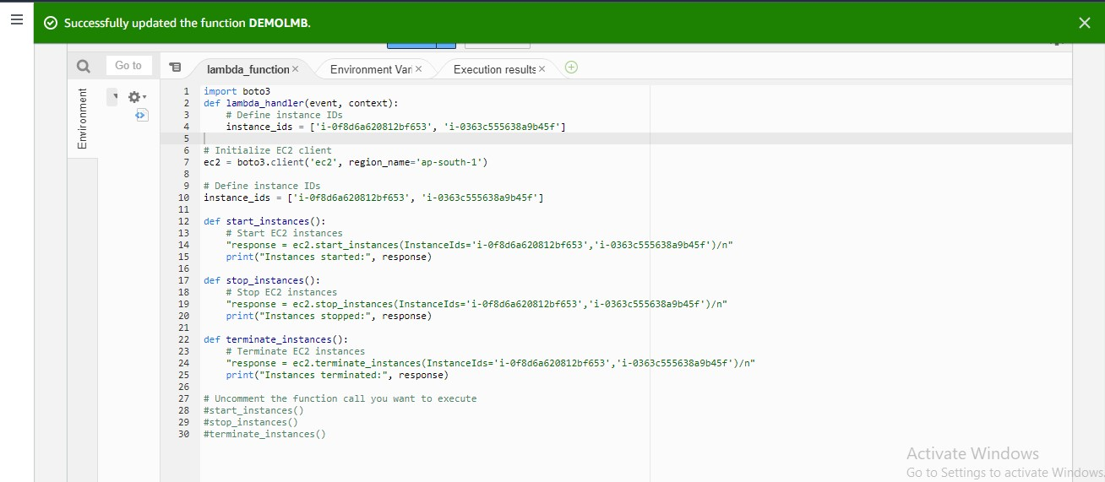

**10)Created two instances both are in running state..below shown in image..**



**11)Role demolmb created for to give permissions to invoke the code And attached to the lambdafunction…**



**12) Before going to auto schedule once checked the code successfully invoked…**

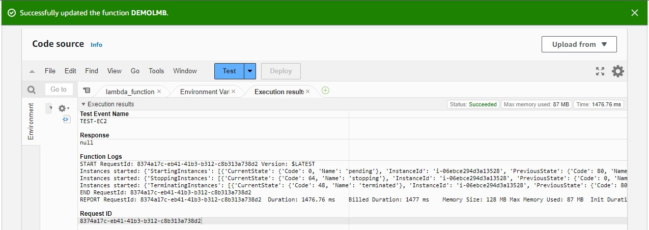

**13)After manually invoke … running instances going to be shut and it will terminated below images will shown…**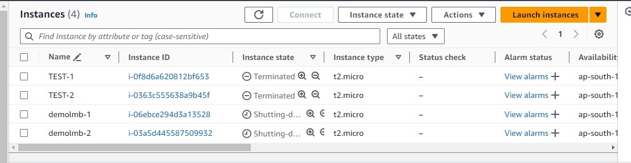

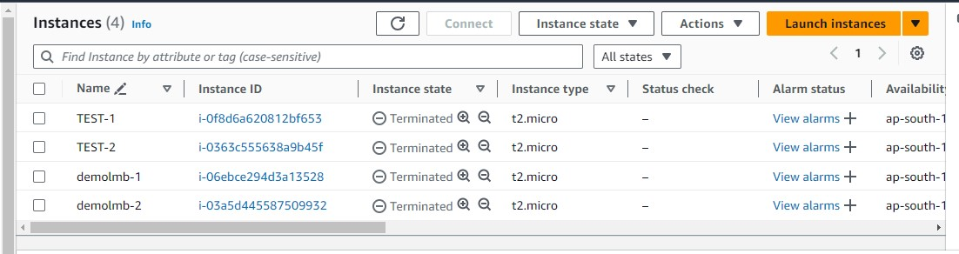

**14) Once cecking status of the code log ..**

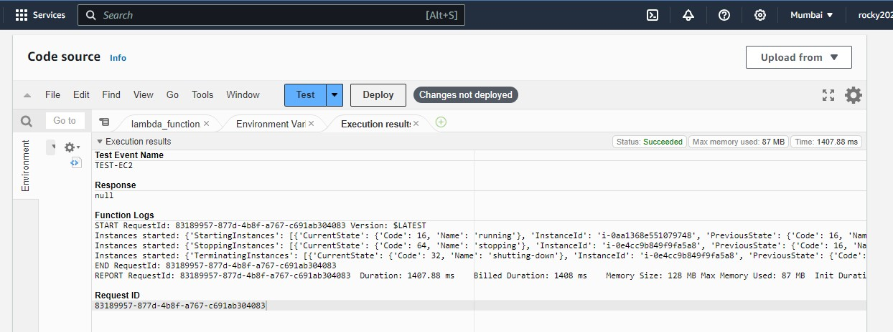

**15)** **Next steps for rules creation for auto trigger the lambda function**…

**A. Go to cloud wact events now it was event bridge.. select the rules to crete new event..**

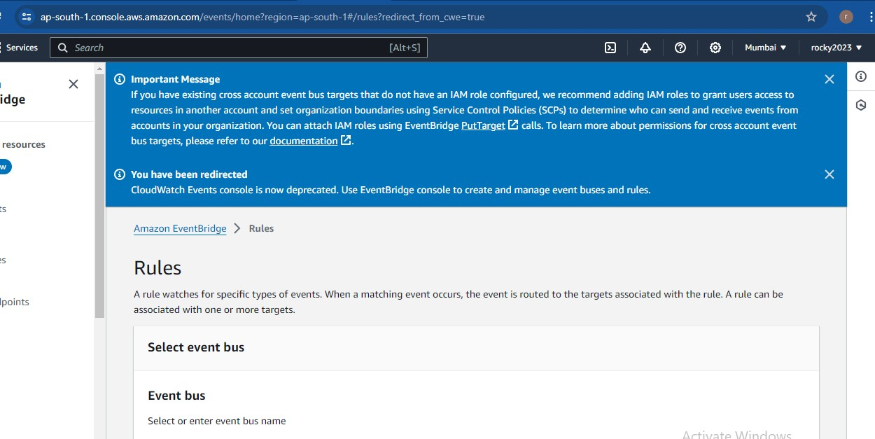

**16)** **Scheduled created successfulyy to auto trigger…**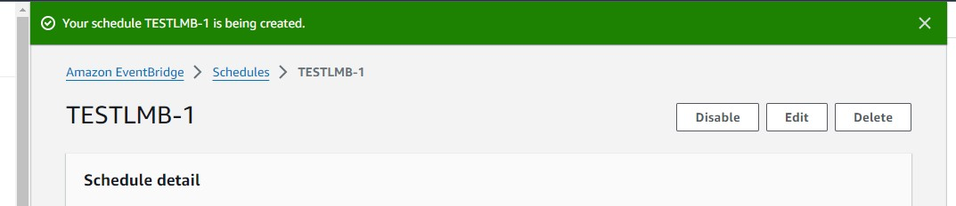

**17) Below image shows the schedule deatil…**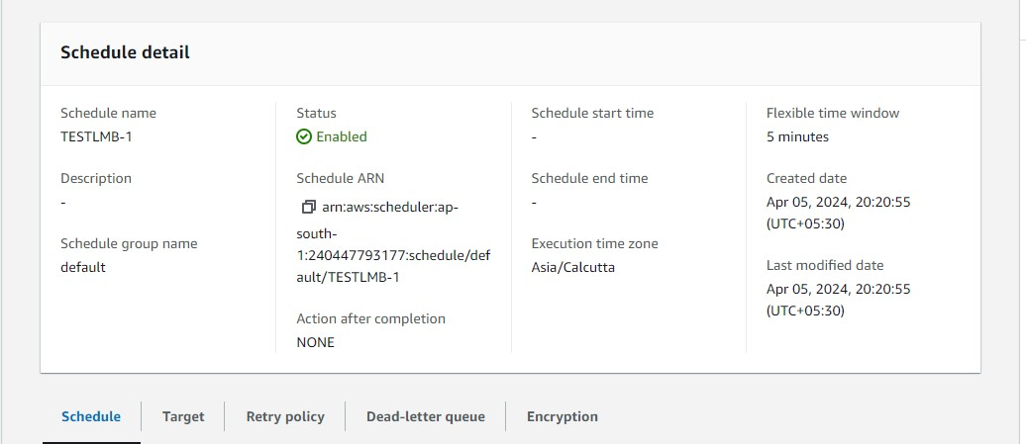

**18) Cron schedule given for auto trigger ….as per utc time schedule entered…but it not worked its fails the job again but manully trigger it works ..**

**A. below image manually triggered job..**

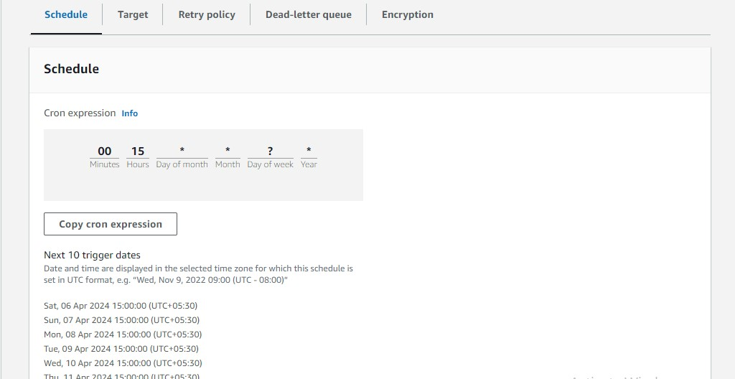

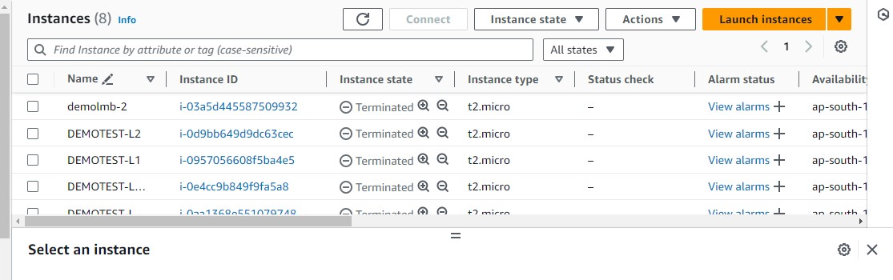

**19)** **Again created new instances to test again by edit the changes in auto schedule…** 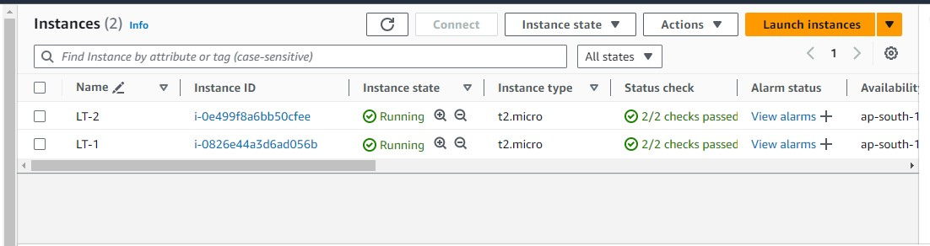

**20) schedule testlmb-1 has saved successfully after some edit the cron time schedule as per the region means system timings after that it works below image shown …**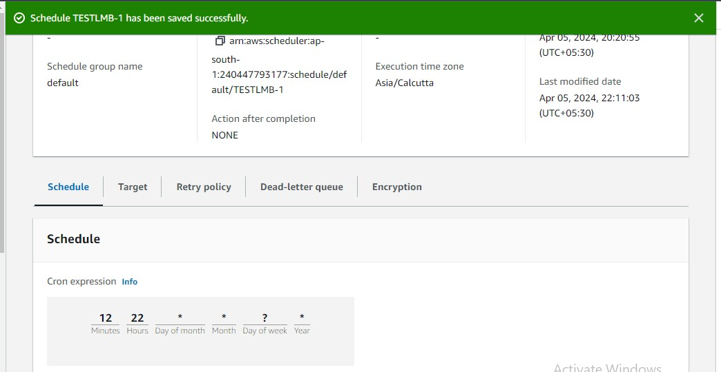

**21)** **Auto triggerred lambda function job running instances stopped ,shutdown and teriminated…**

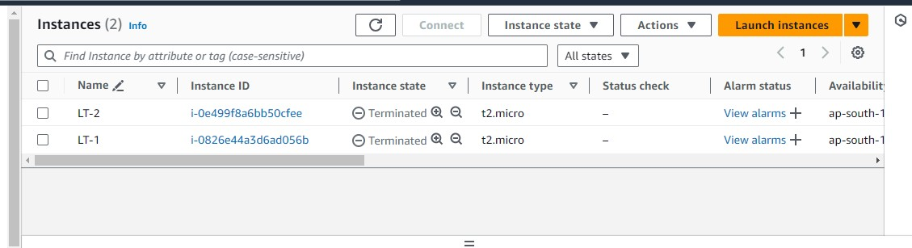

**22) For testing purpose again created two instances named as LT-3 & LT-4..**

**a. Done changes timing in cron schedule ..after changes save it..**

**b.Below 2nd image show cron schedueled timings …**

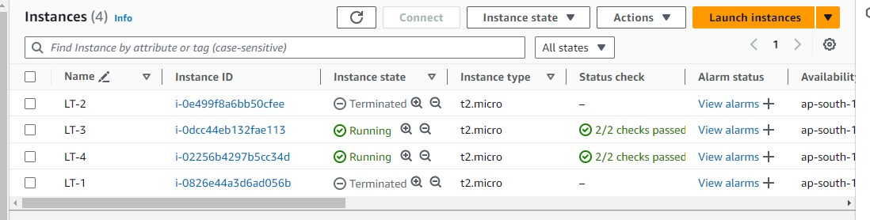



**23)Here auto triggering that running instances stooped and shutting down 1st step…**

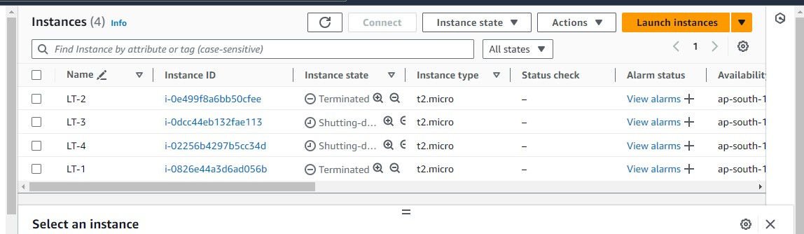

**24) Here after shuttingdown its gettting terminated the ec2instances…it shown in below image…**

